Matlab code implements a mechanistic ODE to solve rate of change of concentrations and recurrent neural network RNN - LSTM to simulate hydrogen redox reactions in porous media,
based on experimental data. It combines:
- Mechanistic ODEs for microbial guilds (methanogens, sulfate reducers, acetogens)
- Parameter fitting to lab data (H₂, CH₄, H₂S, SO₄, CO₂)
- RNN to emulate microbial reaction dynamics in a 1D transport column
- Reactive transport simulation with advection, dispersion, and uncertainty quantification
1. Chemical Reactions Model
The model mainly takes into account three anaerobic redox reactions involving hydrogen as the electron donor.
Reaction | Equation | ΔG (kJ/mol) | Energy Yield Notes
Methanogenesis | 4H₂ + CO₂ → CH₄ + 2H₂O | ~–130 | Highly favorable; supports robust microbial growth
Acetogenesis | 4H₂ + 2CO₂ → CH₃COOH + 2H₂O | ~–95 | Moderate yield; less favorable than methanogenesis
Sulfate Reduction | 4H₂ + SO₄²⁻ + 2H⁺ → H₂S + 4H₂O | ~–152 | Most favorable; dominant when sulfate is abundant
These values are standard Gibbs free energy changes (ΔG) under ideal conditions. In situ yields vary with substrate concentrations, temperature, and pH.
1. Methanogenesis
- 4H₂ + CO₂ → CH₄ + 2H₂O
- Microbial guild: X_meth
- Rate: r_meth
2. Sulfate Reduction
- 4H₂ + SO₄²⁻ + 2H⁺ → H₂S + 4H₂O
- Microbial guild: X_sulf
- Rate: r_sulf
3. Acetogenesis
- 4H₂ + 2CO₂ → CH₃COOH + 2H₂O
- Microbial guild: X_aceto
- Rate: r_aceto
- FeS precipitation: H₂S is removed when it exceeds saturation (H2S_sat)
- Biomass growth: Each guild grows proportionally to its reaction rate and yield
2. ODE System: Rate of Change Equations
Methanogenesis rate equations
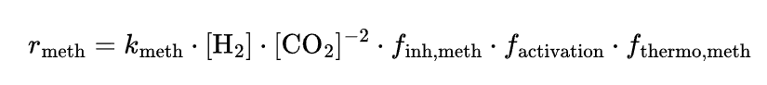
Inhibition
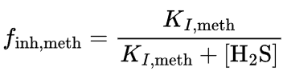
activation
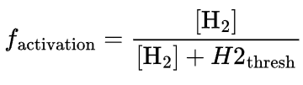
Thermodynamic part
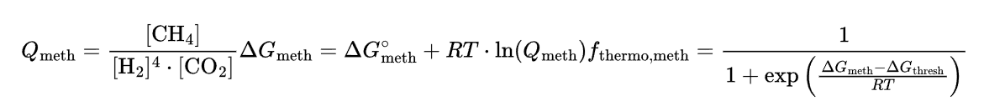
Sulfate reduction rate equations
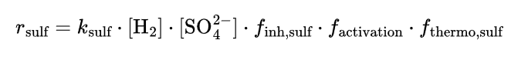
inhibition
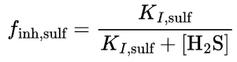
Thermodynamic part
Acetogenesis rate equations
Inhibition
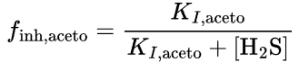
Thermodynamic calculation part
FeS Precipitation Rate
Biomass Growth
Each microbial guild grows proportionally to its reaction rate and yield:
3. RNN Neural Network
After fitting the ODE model, the code:
- Simulates the system over time (xTrain)
- Trains an RNN to predict the next state from a sequence of past 10 states
- Saves the trained model (trained_LSTM_multiguild.mat)
This RNN is then used in the 1D transport simulation to emulate microbial reactions in each cell.
4. 1D Reactive Transport Simulation
The column is 75 m long, discretized into 75 cells. Each time step:
- Advection: shifts concentrations downstream
- Dispersion: smooths gradients
- Reaction: uses the RNN to predict the next state in each cell
- Uncertainty: 20 ensemble predictions per cell → mean + std
Breakthrough curves (BTCs) are recorded at 25 m and plotted with uncertainty bands.

5. plots
BTC_mean , BTC_std: mean and standard deviation of concentrations at 25 m
Plots: 10 subplots (H₂, CO₂, CH₄, H₂S, SO₄, Acetate, FeS, X_meth, X_sulf, X_aceto)
Shaded error bars show model uncertainty from RNN ensemble

